Ciclo Superior Desenvolvemento de Aplicacións Web (2do. DUAL)

Actividad 1.1-

Despliegue de una web estática con AWS Amplify

Alumno:
PÉREZ CARRAL, SANTIAGO

FECHA: 24/09/2026

https://github.com/mrey-profe/voco/compare/master...sodamer0:voco:master

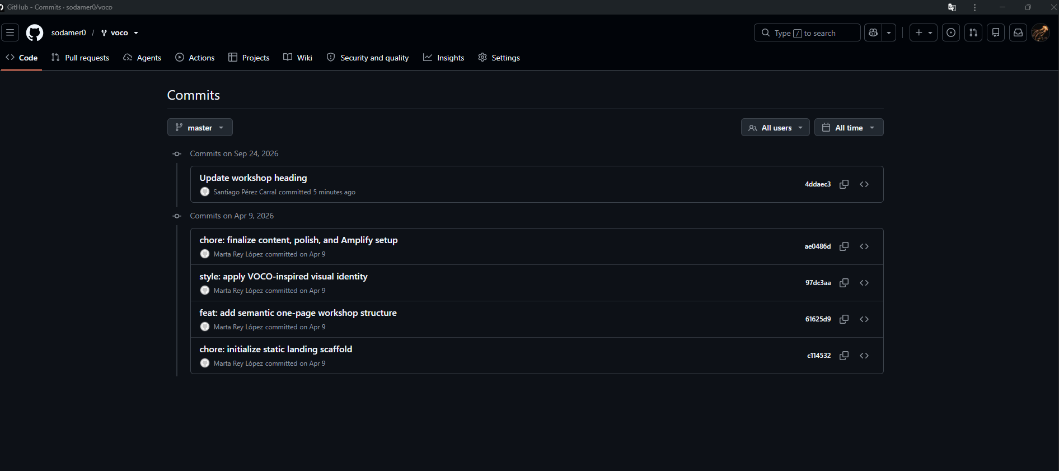

https://github.com/sodamer0/voco

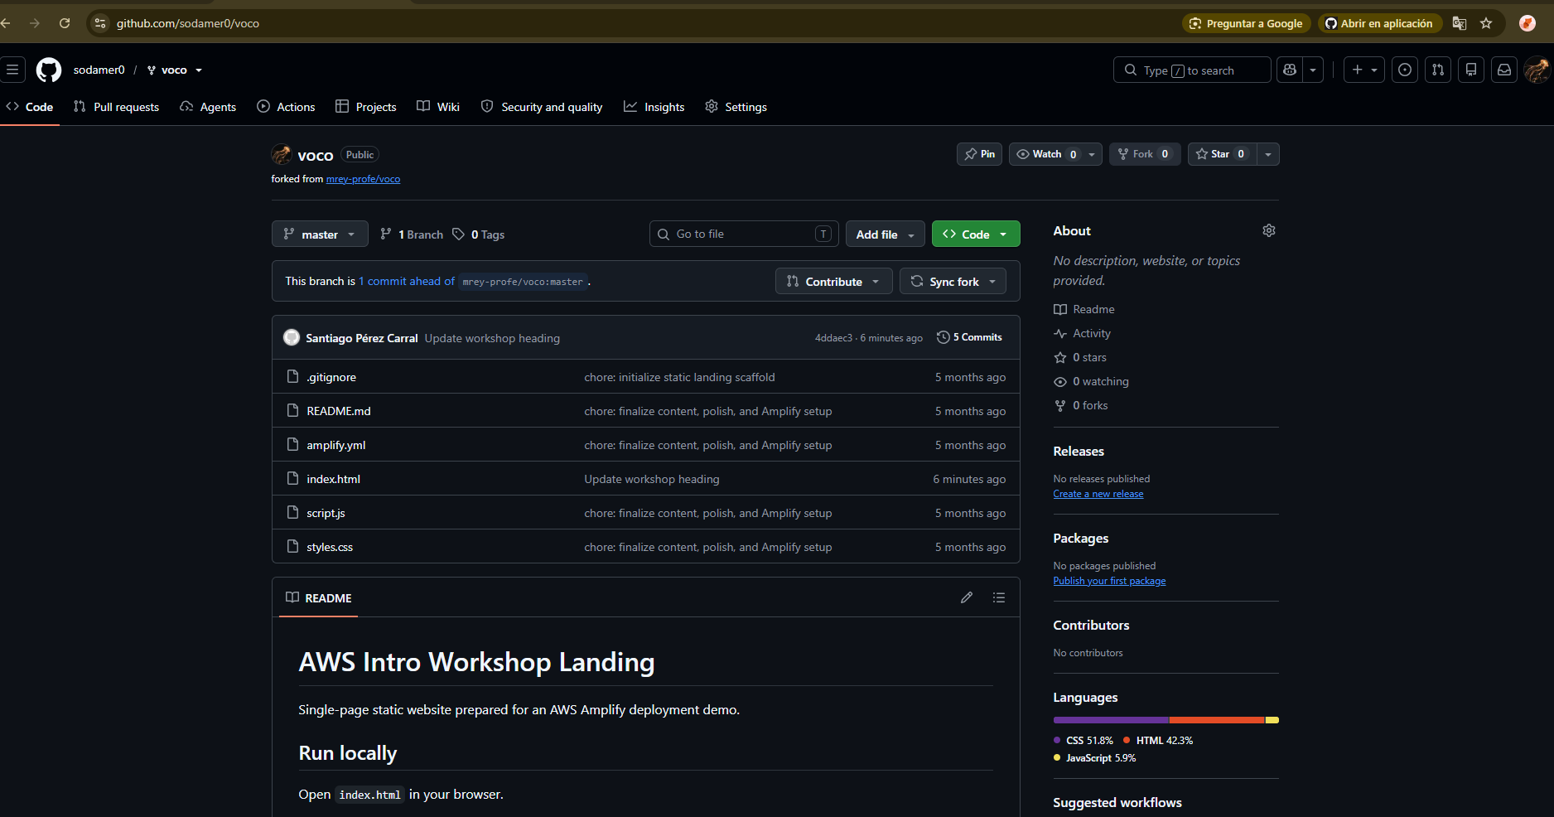

https://master.d1bv9ukxerseoz.amplifyapp.com/

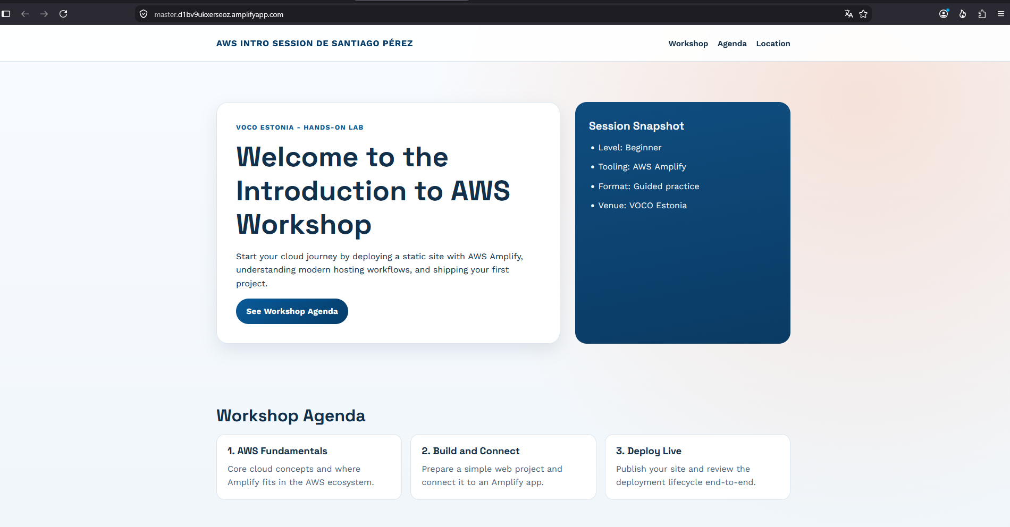

https://us-east-1.console.aws.amazon.com/amplify/apps/d1bv9ukxerseoz/branches/master/deployments?region=us-east-1

